**How to Pull PubMed Metadata for Publication Timeline Analysis**

**[2019.04.10]**

1. Go to <https://www.ncbi.nlm.nih.gov/> and make sure you are looking in the “PubMed” database.

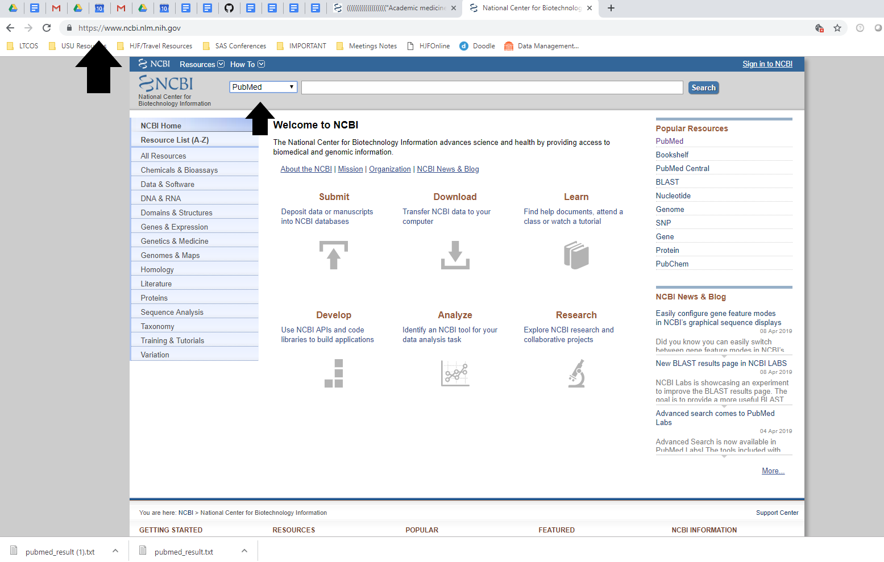

2. Enter the following in the Search bar and click “Search”

((((((((((((((((((("Academic medicine : journal of the Association of American Medical Colleges"[Journal]) OR "Medical education"[Journal]) OR "Medical teacher"[Journal]) OR "The clinical teacher"[Journal]) OR "Perspectives on medical education"[Journal]) OR "BMC medical education"[Journal]) OR "Medical education online"[Journal]) OR "Journal of graduate medical education"[Journal])) OR "International journal of medical education"[Journal]) OR ("Advances in health sciences education : theory and practice"[Journal])) OR ("Teaching and learning in medicine"[Journal])) OR "The Journal of continuing education in the health professions"[Journal]) OR "Journal of medical education"[Journal]) OR "International journal of medical education"[Journal]) OR "Journal of advances in medical education & professionalism"[Journal]) OR "Canadian medical education journal"[Journal]) OR "British journal of medical education"[Journal])) AND ("2007"[Date - Publication] : "2018"[Date - Publication])

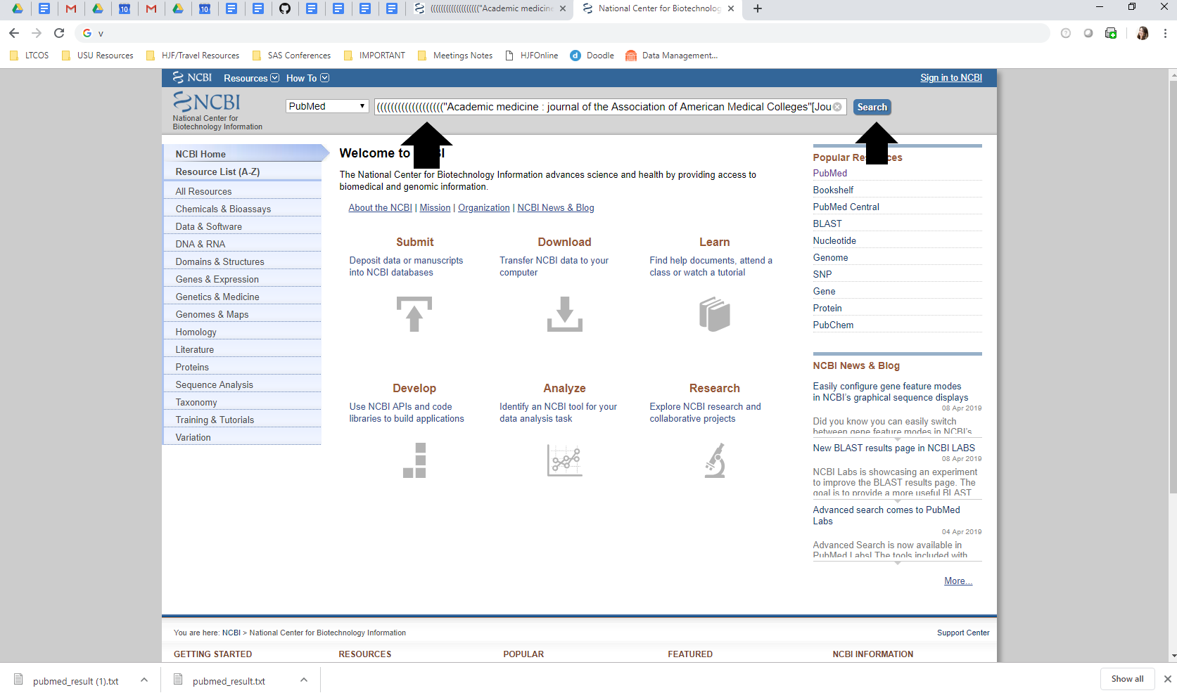

3. Click on “Send To”, Choose “File” as Destination, “Medline” as format, and you can designate your “Sort By” if desired. Then click “Create File”.

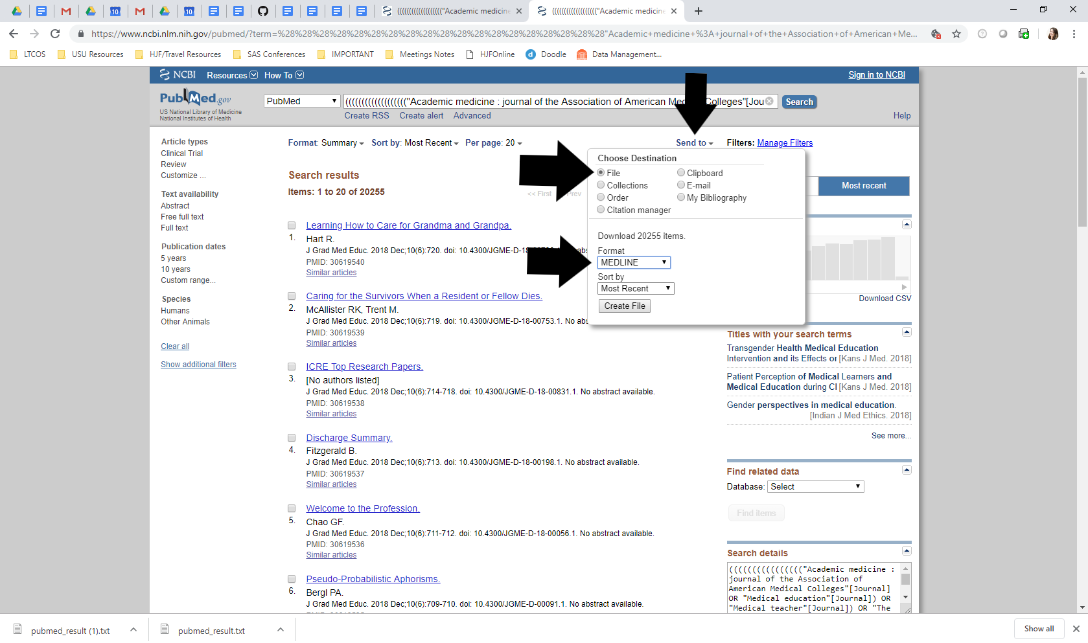

4. Your file will be located in your “Downloads” Folder!!